UNIVERSITY OF SCIENCE AND TECHNOLOGY OF HANOI
DEPARTMENT OF INFORMATION AND COMMUNICATION TECHNOLOGY



BACHELOR THESIS

By
Trương Đại An – 22BI13008

WPF Image Processing Application

Supervisor: Mr. Kiều Quốc Việt

Hanoi, July 2026

Hanoi, <Month – yyyy>

Hanoi, September 2013

HàNội, Sept. 2012
Declaration

I, Truong Dai An, of the Information and Communication Technology Department,
University of Science and Technology of Hanoi, confirm that this is my own work, and that all figures, tables, equations, code snippets, artworks, and illustrations in this report are original and have not been taken from any other person’s work, except where the works of others have been explicitly acknowledged, quoted, and referenced.
I understand that failing to do so will be considered an act of plagiarism. Plagiarism is a form of academic misconduct and will be penalized accordingly.
I give my consent to having a copy of my report shared with future students as an example.
I give my consent for my work to be made available more widely to USTH members and the public with interest in teaching, learning, and research.

Truong Dai An
June 28, 2026

Table of Contents
ACKNOWLEDGEMENTS 7
LIST OF ABBREVIATIONS 8
LIST OF FIGURES 9
ABSTRACT 11
I/ INTRODUCTION 12
1. Context and Motivation 12
2. Aim and Objectives 12
3. Expected outcome 13
4. Thesis structure 14
II/ REQUIREMENTS ANALYSIS 15
1. Overall System Requirements: 15
2. User & Non-functional Requirements: 16
2.1. Target Users 16
2.2. Usability Requirements 16
2.3. Performance Requirements 17
2.4. System Environment 17
3. Use Cases: 17
4. Use Case and Scenario Description 18
4.1. Basic Flow Descriptions 18
4.1.1. Use Case 1: Apply Color Curves Adjustment 18
4.1.2. Use Case 2: Execute Batch Data Augmentation 19
4.1.3. Select Object using GrabCut 20
4.2. Alternative Flow (Test Case Scenarios) 20
4.2.1. Test Case 1: Triggering operations when no image is loaded 20
4.2.2. Test Case 2: Out-of-bounds crop selection coordinates 21
4.2.3. Test Case 3: Entering invalid numeric parameters in text boxes 21
III/ METHODOLOGY 23
1. Overall System Architecture: 23
1.1 . Development Tools 23
1.2. Optimization Techniques 23
2. System Architecture: 24
3. Database Design 24
4. Use Case Implementation 25
4.1 Adjust Colors with Curves (Fine-tune Color Curves) 25
4.1.1 How it works 25
4.1.2 Use Case Diagram 26
4.1.3 Use Case Diagram Explanation 26
4.2. Batch Image Generation (Data Augmentation) 26
4.2.1 How it works 26
4.2.2 Use Case Diagram 27
4.2.3 Use Case Diagram Explanation 27
4.3 Smart Background Removal (GrabCut Object Segmentation) 28
4.3.1 How it works 28
4.3.2 Use Case Diagram 28
4.3.3 Use Case Diagram Explanation 29
IV/ RESULTS 30
1. Accuracy and Processing Speed 30
2. Processing Speeds (Average Latency) 30
3. Accuracy 30
4. Limitations 30
5. Future works 31
REFERENCES 33

ACKNOWLEDGEMENTS
I would like to give my gratitude to Mr. Kieu Quoc Viet for their supporting and their best guidance throughout this project to me.
I'd also like to thank the teachers at the Information and Communication Technology Department - University of Science and Technology of Hanoi (USTH) for facilitating my studies and research.
There will inevitably be flaws in this thesis, even with my best efforts during the learning process. Any insightful criticism and recommendations from all instructors and seniors would be very appreciated in order to raise the caliber of this work.
Lastly, I want to express my gratitude to my friends and family for their unwavering support and encouragement during the entire thesis research process.

Truong Dai An
June 28, 2026

LIST OF ABBREVIATIONS

Abbreviation | Expanded Form
API | Application Programming Interface
BGR | Blue, Green, Red (Standard Color Order in OpenCV)
BGRA | Blue, Green, Red, Alpha (Color Channels with Transparency)
CPU | Central Processing Unit
GPU | Graphics Processing Unit
I/O | Input / Output
LUT | Look-Up Table
ML | Machine Learning
RAM | Random Access Memory
STA | Single-Threaded Apartment (WPF Thread Model)
TPL | Task Parallel Library
UI | User Interface
WPF | Windows Presentation Foundation
XAML | Extensible Application Markup Language

LIST OF FIGURES

ABSTRACT

The project "WPF Image Processing Application" aims to develops a desktop application designed for image processing and data augmentation in computer vision and machine learning workflows. Built on the WPF (C#) framework integrated with the Emgu.CV (OpenCV) library, the application provides an intuitive interface for users to perform basic edits (brightness, contrast, opacity), apply color filters, crop custom selections, and perform intelligent background removal (GrabCut). Furthermore, it integrates a curve graph for non-linear color grading and a batch transformation engine (rotation, flipping, shearing, shifting) to expand training datasets. The system is optimized for high performance, ensuring smooth image processing and real-time previews.

I/ INTRODUCTION

Context and Motivation
Modern smart computer systems (like those that can recognize objects in photos or classify images) need a huge number of different pictures to learn from. However, collecting and labeling thousands of pictures by hand takes a lot of time and effort. To solve this, people often use a method called Data Augmentation. This means creating new versions of existing pictures by changing them slightly—such as rotating them, flipping them, or changing their colors—so the computer has more examples to study.
Currently, most tools used to create these new pictures are code-based. This means users have to write code and run it without seeing what the modified images actually look like until the process is finished. On the other hand, popular image editing software like Adobe Photoshop or GIMP allows users to see changes in real-time, but they are designed for editing one photo at a time and cannot easily generate hundreds of varied images automatically for computer learning.
This project solves these problems by creating a simple Windows app. It combines the easy-to-use controls of a photo editor with the power of automatic image generation. Users can adjust colors, cut out subjects, and apply different filters, while instantly seeing the results on screen. They can then automatically generate and save many different versions of their images all at once.

II/ OBJECTIVES

Aim and Objectives
The main goal of this project is to design, implement, and evaluate an interactive desktop application for image processing and batch data augmentation, with user-friendly desktop application that makes image editing and batch image generation quick and easy.
To achieve this, the following objectives were defined:
- Develop an Interactive User Interface: Implement a responsive WPF-based GUI allowing users to load, preview, and manage a queue of images.
- Integrate Core Image Processing Filters: Build features for adjusting brightness, contrast, and opacity in real-time, along with classic filters (Grayscale, Gaussian Blur, Canny Edge, Sepia, and ColorMaps).
- Implement Advanced Selection and Masking Tools: Implement custom rectangular and elliptical cropping with transparent backgrounds, plus interactive object extraction using the GrabCut algorithm.
- Create a Color Curves Module: Develop a control-point-based canvas allowing users to fine-tune color channels (RGB, R, G, B) and apply adjustments via Look-Up Tables (LUTs).
- Build a Data Augmentation Engine: Provide a configuration panel to define augmentation settings (flips, rotations, shifts, shears) and auto-generate batches of augmented images.
- Optimize Performance: Ensure a fluid user experience by implementing background processing (multi-threading) and memory-efficient image caching.

Expected outcome
The expected outcome is a fully functional Windows desktop application running on NET 9.0. It will enable users to:
- Import multiple image files at once or drag-and-drop them into a queue.
- Interact with real-time editing sliders without experiencing screen freezing or input lag.
- Isolate target objects dynamically and crop them into transparent shapes.
- Generate up to 50 augmented versions of an image at once, automatically named and saved back into the workspace.
- Export the entire processed queue to a directory in a single batch operation.

Thesis structure
This thesis is divided into chapters, each covering a significant aspect of the research.
- CHAPTER I: Introduction
This chapter introduces the context, motivation, research aims, project objectives, expected outcomes, and the structure of the thesis.
- CHAPTER II: Requirements Analysis
This chapter outlines what the application needs to do, including its features, design inspirations, and the programming tools used to build it.
- CHAPTER III: Methodology
This chapter describes the system's architecture, caching/threading techniques, the use case diagram, and detailed use case scenarios with basic/alternative flows.
- CHAPTER IV: Results
This chapter presents performance evaluations, execution speeds, system limitations, and suggestions for future enhancements.
- CHAPTER V: References
The final chapter compiles references that used throughout the project
-

II/ REQUIREMENTS ANALYSIS
This is one of the most important parts, as it is the foundation of any project, helping the operation process to be smooth and less prone to errors. This chapter will examine a brief review of the app’s functions and the system scenarios and use cases.

Overall System Requirements:
The primary goal of this application is to provide a simple and user-friendly tool for editing images and generating multiple variations of them in batches.
The software must handle the following core functions:
- Image Management: Users should be able to open multiple images at once, view them in a list, and select which one to edit.
- Simple Editing: Users should be able to adjust basic image qualities like brightness, contrast, and transparency using simple sliders, and apply standard filters like black-and-white or blur.
- Smart Selection and Background Removal: Users should be able to draw shapes to crop images or use a smart tool to automatically separate a subject from its background.
- Color Tuning: Users should be able to adjust color channels precisely using a visual graph.
- Batch Image Generation: Users should be able to set options to flip, rotate, or shift an image to automatically create and save many different versions of it.
- Exporting: Users should be able to save their work or export all images in the list to a folder in one action.
The system processes these actions through a simple step-by-step workflow: 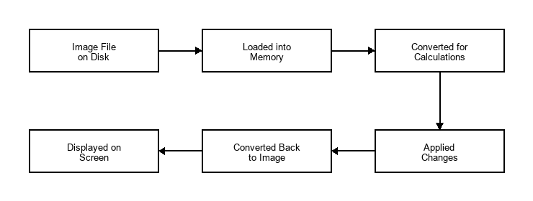
Figure 1: Operation Method Diagram
- Loading the Image: The app opens the picture file from your computer's storage and holds it in the app's memory without locking the file.
- Converting the Image: The app translates the picture into a format of numbers that the computer can easily calculate.
- Processing the Changes: The app performs fast mathematical calculations to apply the adjustments or filters you chose.
- Showing the Result: The app converts the calculated numbers back into a regular picture and displays it on your screen immediately.

User & Non-functional Requirements:

Target Users
- Machine Learning Developers and Researchers: Who need to quickly generate hundreds of varied training images (data augmentation) for their smart computer systems.
- General Users and Editors: Who want a simple, lightweight tool to edit pictures, adjust colors, and remove backgrounds without using complex professional software.

Usability Requirements
- The interface must be clean and intuitive, using familiar controls like sliders, text boxes, and buttons.
- Visual controls (like the color curves graph) must update the image preview instantly to give the user immediate feedback.

Performance Requirements
- Image adjustments must respond smoothly as the user drags sliders, without lagging or stuttering.
- The application must perform heavy calculations in the background so the user interface never freezes or becomes unresponsive.
- Large images (including high-resolution photos) must be handled safely without causing the application to crash or run out of memory.

System Environment
- The application is designed to run locally on Windows computers. It does not require an active internet connection to edit or generate images.

Use Cases:
The following Use Case relationships represent the system interactions:
- Queue Management: Adding images to the list, clearing the list, and selecting an image.
- Editing & Filters: Adjusting brightness, contrast, and transparency, applying filters, and using the undo/redo features.
- Selection & Masking: Cropping images into shapes or using the smart background remover.
- Image Generation: Setting parameters and running the batch image creator.
- Saving & Exporting: Saving changes to a single file or exporting the entire list to a folder.
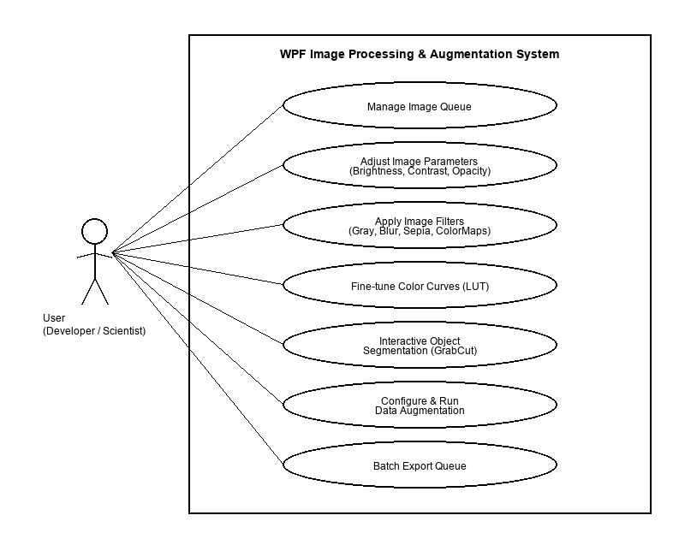
Figure 2: Use Case

Use Case and Scenario Description
  - Basic Flow Descriptions
    - Use Case 1: Apply Color Curves Adjustment
Description: The user adjusts the color tone of the image using a graphical curves grid (RGB, R, G, B channels).
Actor Action | System Action | Data
1. Click the "Chỉnh màu (Curves)" menu item. | Open the CurveWindow modal and display the active image preview. | Selected image (BitmapSource) passed to child window.
2. Select channel (e.g., "Kênh Đỏ (R)") and click/drag control points on the canvas. | Recalculate spline curve coefficients, update grid rendering, generate a 256-byte Look-Up Table (LUT), and update preview in real-time. | Array of 2D control points. LUT array (1x256 bytes).
3. Click the "Áp dụng" button. | Close CurveWindow. Apply the generated LUT to the image on a background thread. Render on main window. | Mat applied with CvInvoke.LUT.

    - Use Case 2: Execute Batch Data Augmentation
Description: The user configures transformations to generate multiple variations of the active image.
Actor Action | System Action | Data
1. Click the "Data Augmentation" menu item. | Open the AugmentWindow showing settings sliders (Rotate, Shear, Shift, Count). | Selected image passed to child window.
2. Adjust parameters (e.g., Check "Lật dọc", set Rotate to 30°, Count to 5) and click "Áp dụng". | Close AugmentWindow. Generate 5 unique transformed images on background threads using Affine matrices. | Rotation angle (degrees), Shear (degrees), translation coordinates, and Count integer.
3. View main image queue. | Add the newly generated images to the queue list with suffix _aug_{suffix} and save them to the directory cache. | List of new file paths and generated Mat/BitmapSource objects.

    - Select Object using GrabCut
Description: The user draws a rectangle around an object to isolate it and apply transparency to the background.
Actor Action | System Action | Data
1. Click the "Chọn đối tượng (GrabCut)" menu item. | Activate selection mode. Disable image panning/zooming. Show selection canvas. | Selection state flags set to true.
2. Drag mouse to draw a box around the object on the canvas. | Draw a dashed cyan rectangle over the image. | Mouse coordinates on Canvas (Start X/Y, End X/Y).
3. Click the "Cắt ảnh vùng chọn" button. | Convert coordinates to image scale. Run GrabCut asynchronously. Extract foreground object, refine boundary, add alpha transparency, and update preview. | Bounding box coordinates, generated GrabCut mask, resulting transparent BGRA Mat.
  - Alternative Flow (Test Case Scenarios)
    - Test Case 1: Triggering operations when no image is loaded
- Scenario: The user launches the application and immediately clicks "Chỉnh màu (Curves)" or adjusts the Brightness slider.
- System Response: The system checks if imgPreview.Source is null. If true, the system ignores slider inputs and displays a warning dialog saying: "Vui lòng chọn ảnh trước khi xem trước!" or "Không có dữ liệu ảnh!". No crash occurs.
    - Test Case 2: Out-of-bounds crop selection coordinates
- Scenario: The user draws a selection box that extends outside the visual bounds of the image preview container.
- System Response: When the cropping operation is triggered, the system intercepts the relative coordinates of the drawn rectangle on the UI canvas. To prevent a memory access violation (which would happen if the application attempted to crop outside the boundaries of the image matrix), the system performs a defensive boundary intersection check:
- Coordinate Translation: The coordinates from the visual canvas are converted to the physical pixel coordinate space of the underlying Mat image, adjusting for the current scaling factor.
- Boundary Clamping: The system instantiates a geometric rectangle representing the exact bounds of the image (from index 0 to the maximum width and height) and intersects it with the user's selection rectangle. This process trims any out-of-bounds selection coordinates, clamping them strictly to the image borders.
- Zero-Area Check: If the resulting intersected rectangle has zero width, height, or area (indicating that the user's selection was drawn entirely outside the image boundary), the cropping task is aborted. The system returns the original image unmodified without throwing an exception.
- Memory-Safe Execution: If the intersection area is valid, only the safe, clamped sub-matrix is extracted. This ensures that memory boundaries are respected, preventing application crashes while seamlessly adjusting to the user's boundary limits.
    - Test Case 3: Entering invalid numeric parameters in text boxes
- Scenario: The user types letters (e.g., "abc") or extreme values into the Brightness textbox next to the slider and hits Enter.
- System Response: The system handles inputs defensively within the key press and text-change event handlers:
- Input Parsing & Validation: The system attempts to parse the text string using a secure conversion utility (double.TryParse). If the parsing fails (e.g., the input contains letters, symbols, or is empty), the system rejects the input. It rolls back the text box content to match the current valid slider value, preventing conversion or formatting exceptions.
- Range Clamping: If the input parses successfully but falls outside the acceptable range (for example, typing 500 or -350 when the brightness limits are -100 and 100), the system clamps the value. It applies mathematical limit operations (Math.Max and Math.Min) to force the input to the nearest boundary (clamping 500 down to 100, and -350 up to -100).
- UI Control Synchronization: The validated and clamped value is then synchronized with the slider control (sliderBrightness.Value). This update automatically propagates through the image processing pipeline, rendering the preview correctly. The text box is updated with the clamped value, ensuring that the textual inputs and visual sliders remain perfectly in sync.

III/ METHODOLOGY
This section describes what I used and did on this project, including details of what the design consisted of, how it was done, and a section for a comparison between the original design and what I ended up creating.

Overall System Architecture:

. Development Tools
- Visual Studio: The environment used to write and organize the program's code.
- .NET and WPF: Microsoft technologies used to design and build the windows, buttons, and sliders.
- Emgu.CV (OpenCV): A fast software library used to perform all the heavy image calculations like blurring, resizing, and cutting out backgrounds.

1.2. Optimization Techniques
- Memory Caching: To keep the app running fast, the system stores active images in the computer's temporary memory (RAM) after they are loaded or edited. This avoids reading files from the hard drive repeatedly, which would slow the app down.
- Background Processing: Heavy image calculations (like removing backgrounds or generating dozens of new images) are performed on separate background tasks. This keeps the main user interface responsive so the window never freezes.
- Input Throttling: When a user drags a slider, it triggers changes very quickly. To prevent overloading the computer, the app waits for a brief fraction of a second (50 milliseconds) after the user stops dragging before applying the changes.

System Architecture:
The application is organized into three distinct layers, as shown in the diagram below:
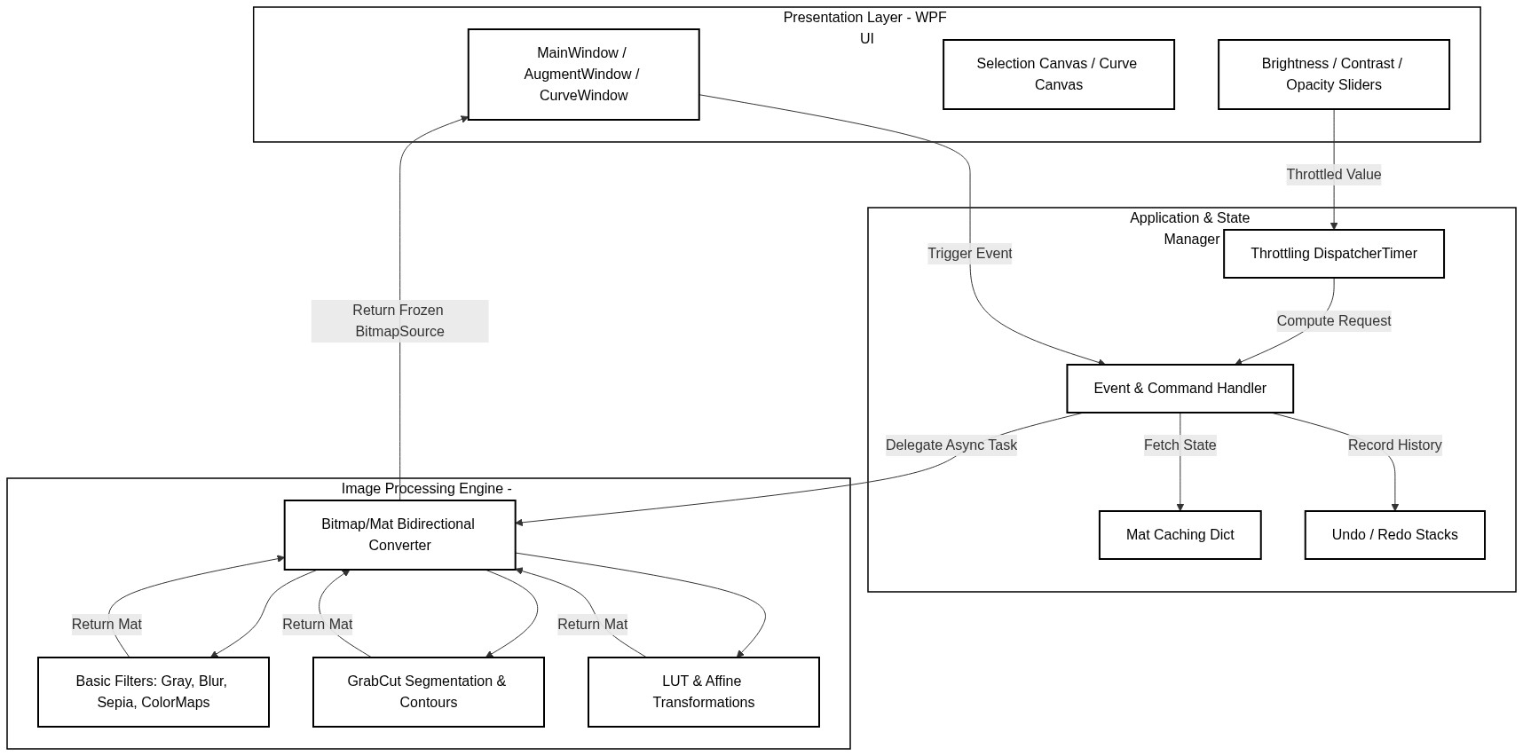

- Presentation Layer: This is the visual interface that the user sees and interacts with (the windows, buttons, sliders, and drawing canvas).
- Application Manager: The middle layer that coordinates actions. It handles events (like button clicks), manages the list of images, keeps track of undo/redo actions, and coordinates background tasks.
- Image Processing Engine: The core calculating layer. It performs the mathematical operations on the image pixels, such as applying filters, adjusting colors, and calculating transparent borders.

Database Design
This application is designed as a lightweight, local desktop utility. As such, it does not require a traditional database management system (like SQL).
Instead, the data storage model works as follows:
- File Storage: All source images and generated images are read from and written directly to the computer's local hard drive folders.
- Memory Storage: Temporary data (such as the list of loaded images, current slider values, and undo/redo history) is kept in the computer's temporary memory (RAM) while the app is running and is discarded when the app is closed.

Use Case Implementation
This section analyzes and explains in detail how each core use case is implemented in the application, using simple concepts without any code blocks.

4.1 Adjust Colors with Curves (Fine-tune Color Curves)
This feature allows users to adjust the red, green, blue, or overall color values of the image by clicking and dragging control points on a visual graph.
    - How it works
- Visual Control Points: The system renders a graph where the horizontal axis represents the input color value (0 to 255) and the vertical axis represents the output color value (0 to 255). Users can place control points on this grid and move them.
- Curve Calculation: When control points are moved, the system calculates a smooth spline curve that connects all the points. This curve maps every possible input color value to a corresponding output color value.
- Lookup Table (LUT): Rather than calculating this mapping for millions of image pixels individually (which would be extremely slow), the system generates a single array of 256 bytes (a Lookup Table). For each possible input value (0 to 255), the table stores the pre-calculated output value.
- Applying to Pixels: Finally, the system scans the image pixels and replaces each color channel value with the corresponding value from the Lookup Table. This process is extremely fast and allows real-time color updates as the user moves points on the graph.
    - Use Case Diagram
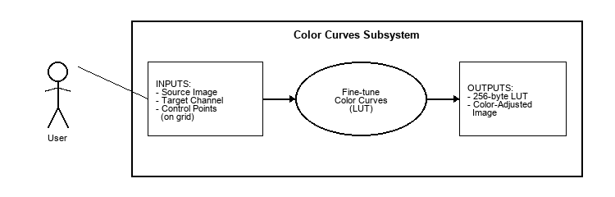
Figure 3: Color Curves Use Case Diagram
    - Use Case Diagram Explanation
This diagram describes the interaction between the user and the system during the color adjustment process:
- Actor (User): The person interacting with the system, who initiates the color curves interface and manipulates the visual controls.
- Inputs: The user provides the selected source image, chooses the target color channel to modify, and adds or drags control points on the graphical grid to define the desired color adjustment.
- Use Case (Fine-tune Color Curves): The core system process that takes the inputs, computes the mathematical spline mapping curves, and compiles the final lookup table.
- Outputs: The system outputs a pre-calculated 256-byte Lookup Table (LUT) and applies it to update the pixels, rendering a color-adjusted image preview on the screen.

4.2. Batch Image Generation (Data Augmentation)
This feature automatically generates multiple modified versions of an image based on the user's settings, such as rotation angles, flipping, and translation shifts.

4.2.1 How it works
- User Parameters: The user inputs the desired ranges for changes (for example, rotation between -30 and 30 degrees, vertical flipping enabled) and the total number of images to generate.
- Coordinate Math (Affine Matrices): For each generated image, the system calculates a mathematical matrix representing the spatial changes. This matrix determines how much each pixel's coordinate should shift, rotate, or shear.
- Executing Transformations: The system applies this matrix to recalculate the positions of all pixels from the original image, generating a new, transformed image. Flipping is handled by reversing pixel coordinate indices.
- Automated Queue and Saving: The generated images are automatically assigned unique file names (using suffixes) and added to the application's list. They are then written directly to the computer's hard drive folders in the background, preventing the user interface from freezing.
    - Use Case Diagram
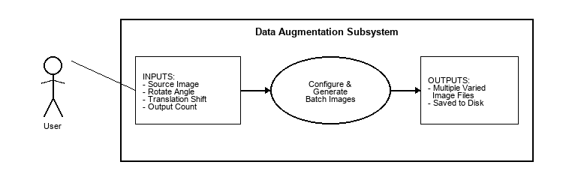
*Figure: Data Augmentation Use Case Diagram*
    - Use Case Diagram Explanation
This diagram illustrates the batch generation workflow:
- Actor (User): The developer or machine learning engineer who configures the parameters for dataset preparation.
- Inputs: The user provides the base source image, sets the transformation limits (rotation angles, shifting distances, flipping preferences), and specifies the number of output images to create.
- Use Case (Configure & Generate Batch Images): The system process that runs background tasks to calculate transformation coordinates and construct new image matrices.
- Outputs: The system creates multiple unique image variations and saves them directly to the local disk folders, naming each file systematically.

4.3 Smart Background Removal (GrabCut Object Segmentation)
This feature allows users to draw a box around a subject, and the system automatically cuts out the subject by removing the background and making it transparent.
    - How it works
- Drawing the Box: The user draws a box around the object. The system maps the box coordinates from the visual screen to the actual pixel coordinates of the image.
- Foreground-Background Math: The system runs a segmentation algorithm (GrabCut) that analyzes the colors of the pixels inside the box compared to the colors outside the box. It does this over several iterations to classify each pixel as either "definitely background", "definitely foreground", "probably background", or "probably foreground".
- Creating a Border Silhouette (Contour): Once classification is complete, the system finds the boundaries of the foreground object. It selects the largest continuous shape (the main subject) and discards smaller, scattered noise pixels. It then applies a smoothing step to make the borders clean.
- Applying Transparency: The original image is converted from three color channels (Red, Green, Blue) to four channels (Red, Green, Blue, Alpha). The Alpha channel controls transparency. The system sets the alpha values of all background pixels to zero (making them invisible) and keeps the foreground pixels fully visible.
    - Use Case Diagram
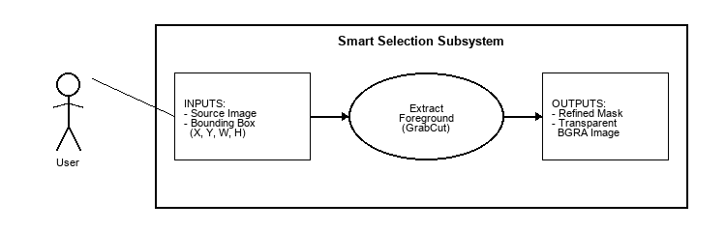
*Figure: Smart Selection Use Case Diagram*
    - Use Case Diagram Explanation
This diagram describes the background extraction process:
- Actor (User): The editor who defines the crop area and initiates the background removal command.
- Inputs: The user provides the source image containing the subject and draws a bounding box (coordinates, width, height) to isolate the target object.
- Use Case (Extract Foreground): The system process that runs the iterative segmentation math, traces contours, refines border silhouettes, and constructs transparency masks.
- Outputs: The system produces a refined binary segmentation mask and outputs a transparent BGRA image preview with the background removed.

IV/ RESULTS

Accuracy and Processing Speed
Performance metrics were gathered by testing the application with images of varying resolutions (Full HD 1920x1080 and Ultra HD 3840x2160) on a standard Windows desktop machine (Intel Core i7 CPU, 16GB RAM, SSD storage).

Processing Speeds (Average Latency)
- Basic Adjustments (Brightness, Contrast, Opacity):
- Without Caching: 120ms to 250ms (noticeable rendering stutter during dragging).
- With Caching & 50ms Throttling: 5ms to 12ms per frame updates. Stuttering was fully eliminated.
- Core Filters (Grayscale, Blur, Sepia, ColorMaps):
- Execution Time: 2ms to 8ms for Full HD; 15ms to 35ms for 4K images.
- Advanced Tools (GrabCut Segmentation):
- Execution Time: 180ms to 320ms for Full HD; 1200ms to 1800ms for 4K. GrabCut is an iterative optimization algorithm, making it computationally expensive. Because it runs asynchronously, the UI remains responsive (users can cancel or interact with other tools while processing).

Accuracy
- Crop and Selection: Transparent boundary cropping (Ellipse and GrabCut) maintains absolute pixel alignment. Elliptical crops successfully output transparent pixels outside the ellipse border instead of black boxes.
- Data Augmentation: Output dimensions, rotation angles, and shear matrices match mathematical expectations precisely. The generated dataset images maintain identical channels and bit depths.

Limitations
Despite meeting the core objectives, some system limitations were identified:
- Operating System Dependency: The application is built on WPF, which is a Windows-only desktop technology. It cannot run on macOS or Linux environments.
- CPU Bottlenecks: Heavy OpenCV operations (especially GrabCut and Large Kernels in Gaussian Blur) run on the CPU. The native C++ implementation is fast, but without dedicated GPU hardware acceleration (CUDA/OpenCL), processing 4K or 8K images still creates a processing latency of over a second.
- Memory Footprint: Caching Mat objects in memory speeds up slider adjustments but increases RAM consumption, particularly when the image queue contains dozens of high-resolution files.

Future works
To address these limitations, the following improvements are proposed for future development:
- Cross-Platform Migration: Refactor the Presentation Layer using modern cross-platform frameworks like Avalonia UI or .NET MAUI to enable compatibility with macOS and Linux.
- GPU Acceleration: Implement GPU support by compiling Emgu.CV with CUDA integration (CudaInvoke), allowing near-instantaneous execution of GrabCut and complex filter pipelines.
- Machine Learning Model Export: Allow the Data Augmentation engine to directly export configuration profiles in JSON or YAML formats compatible with
standard deep learning training libraries like PyTorch or TensorFlow.
- AI-Assisted Segmentation: Integrate lightweight on-device segmentation models (such as MobileSAM) to enable smart object selection with a single mouse click, replacing the iterative GrabCut algorithm.

REFERENCES

Emgu CV Library & Wiki:
- Description: The main documentation, tutorial guides, and source repository for Emgu CV, the cross-platform .NET wrapper used to call OpenCV functions.
- URL: [http://www.emgu.com/wiki](http://www.emgu.com/wiki)
- GitHub: [https://github.com/emgucv/emgucv](https://github.com/emgucv/emgucv)

OpenCV (Open Source Computer Vision Library):
- Description: The official reference documentation for native OpenCV algorithms, including matrix transformations, color maps, and filtering.
- URL: [https://opencv.org/](https://opencv.org/)

GrabCut Segmentation Algorithm:
- Citation: Rother, C., Kolmogorov, V., & Blake, A. (2004). "GrabCut": interactive foreground extraction using iterated graph cuts. ACM Transactions on Graphics (TOG), 23(3), 309-314.
- DOI: [https://doi.org/10.1145/1015706.1015720](https://doi.org/10.1145/1015706.1015720)

Windows Presentation Foundation (WPF) Architecture:
- Description: Official Microsoft documentation detailing the WPF rendering pipeline, thread management (STA model), and the Freezable object class.
- URL: [https://learn.microsoft.com/en-us/dotnet/desktop/wpf/advanced/wpf-architecture](https://learn.microsoft.com/en-us/dotnet/desktop/wpf/advanced/wpf-architecture)

Data Augmentation in Computer Vision:
- Citation: Buslaev, A., Iglovikov, V. I., Khvedchenya, E., Parinov, A., Kurilyak, M., & Kalinin, A. A. (2020). Albumentations: fast and flexible image augmentations. Information, 11(2), 125.
- DOI: [https://doi.org/10.3390/info11020125](https://doi.org/10.3390/info11020125)

Digital Image Processing Principles:
- Citation: Burger, W., & Burge, M. J. (2016). Digital Image Processing: An Algorithmic Introduction Using Java. Springer.
- DOI: [https://doi.org/10.1007/978-1-4471-6684-9](https://doi.org/10.1007/978-1-4471-6684-9)
- Companion Website: [https://imagingbook.com/](https://imagingbook.com/)
- Description: Standard reference for color space representations, affine transformation matrices, and lookup table (LUT) mapping.

